Supplementary Materials
Title: Can empirical catch allocation strategies based on single-region stock assessments provide adequate advice for managing spatially structured fish populations?
Running Title: Catch allocation for spatially structured populations
Authors:
Chengxue Li^{1,6,7}, Jonathan J. Deroba¹*, Daniel R. Goethel², Aaron M. Berger³, Amy M. Schueller⁴, Brian J. Langseth⁵, Emily M. Liljestrand¹, Dana H. Hanselman², Timothy J. Miller¹
Affiliations
¹ Northeast Fisheries Science Center, NMFS–NOAA, 166 Water St., Woods Hole, MA 02543, USA
² Alaska Fisheries Science Center, Auke Bay Laboratories, NMFS–NOAA, 17109 Point Lena Loop Road, Juneau, AK 99801, USA
³ Northwest Fisheries Science Center, Fisheries Resource and Monitoring Division, NMFS–NOAA, 2032 S.E. OSU Drive, Newport, OR 97365, USA
⁴ Southeast Fisheries Science Center, Beaufort Laboratory, NMFS–NOAA, 101 Pivers Island Road, Beaufort, NC 28516, USA
⁵ Northwest Fisheries Science Center, NMFS–NOAA, 2725 Montlake Blvd E, Seattle, WA 98112, USA
⁶ School of Marine and Atmospheric Sciences, Stony Brook University, Stony Brook, NY 11794, USA
⁷ Institute for Advanced Computational Science, Stony Brook University, Stony Brook, NY 11794, USA
* Corresponding author: Jonathan J. Deroba (jonathan.deroba@noaa.gov)

Supplementary Tables
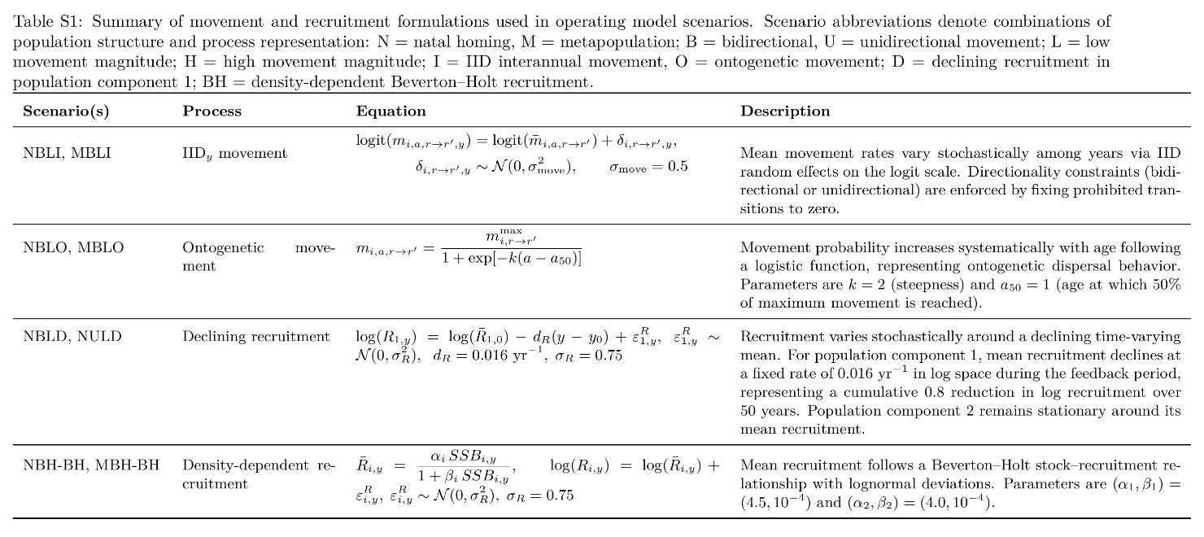
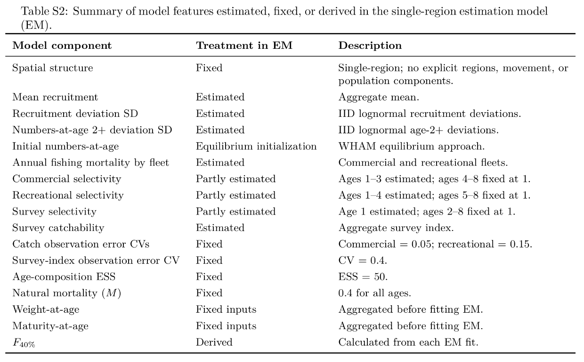

Supplementary Figures
Figure S1 shows an example trajectory from one NBL realization. Figures S2-S5 show metric-specific variation and risk outputs for the six main-text OM scenarios. Figures S6-S11 show the corresponding metric-specific outputs for the full OM scenario set. Figures S12-S14 summarize the full OM scenario set using the summed scaled performance-score framework.

Figure S1. Example operating-model trajectories from one stochastic realization of the BSB-conditioned baseline scenario (NBL). Lines show catch and spawning stock biomass (SSB) for Region 1, Region 2, and the system-level aggregate. The historical period (1989-2023) is shown in black, and the feedback period (2024-2073) is shown by catch allocation strategy. This figure illustrates the closed-loop simulation structure and strategy-specific divergence within a single realization; performance summaries in the main text are based on 100 retained realizations per OM scenario.
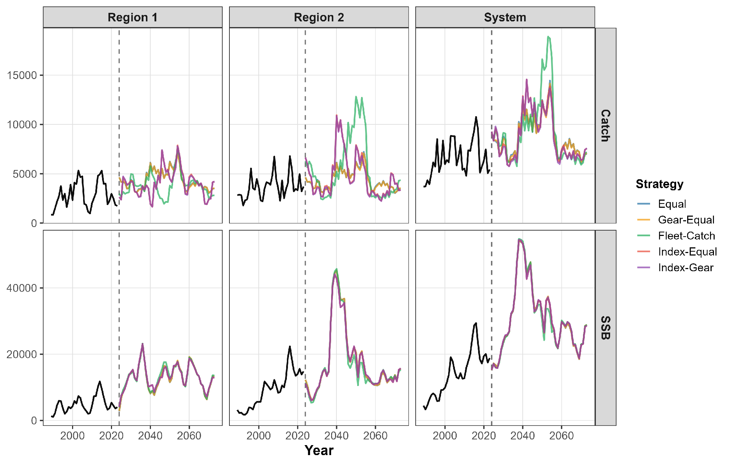

Figure S2. Average annual variation (AAV) in catch across catch allocation strategies, spatial scales, and the six main-text operating model scenarios. Lower values indicate more stable catch over the feedback period.
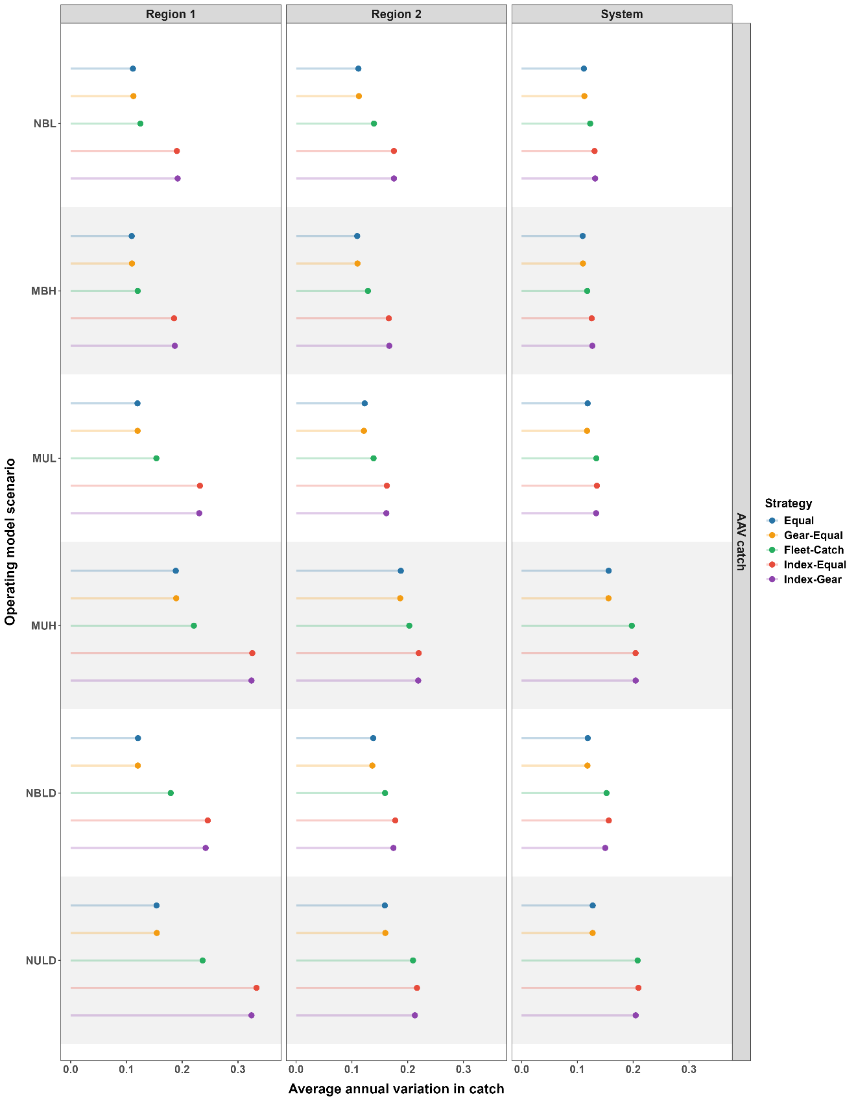
Figure S3. Average annual variation (AAV) in spawning stock biomass (SSB) across catch allocation strategies, spatial scales, and the six main-text operating model scenarios. Lower values indicate more stable SSB over the feedback period.
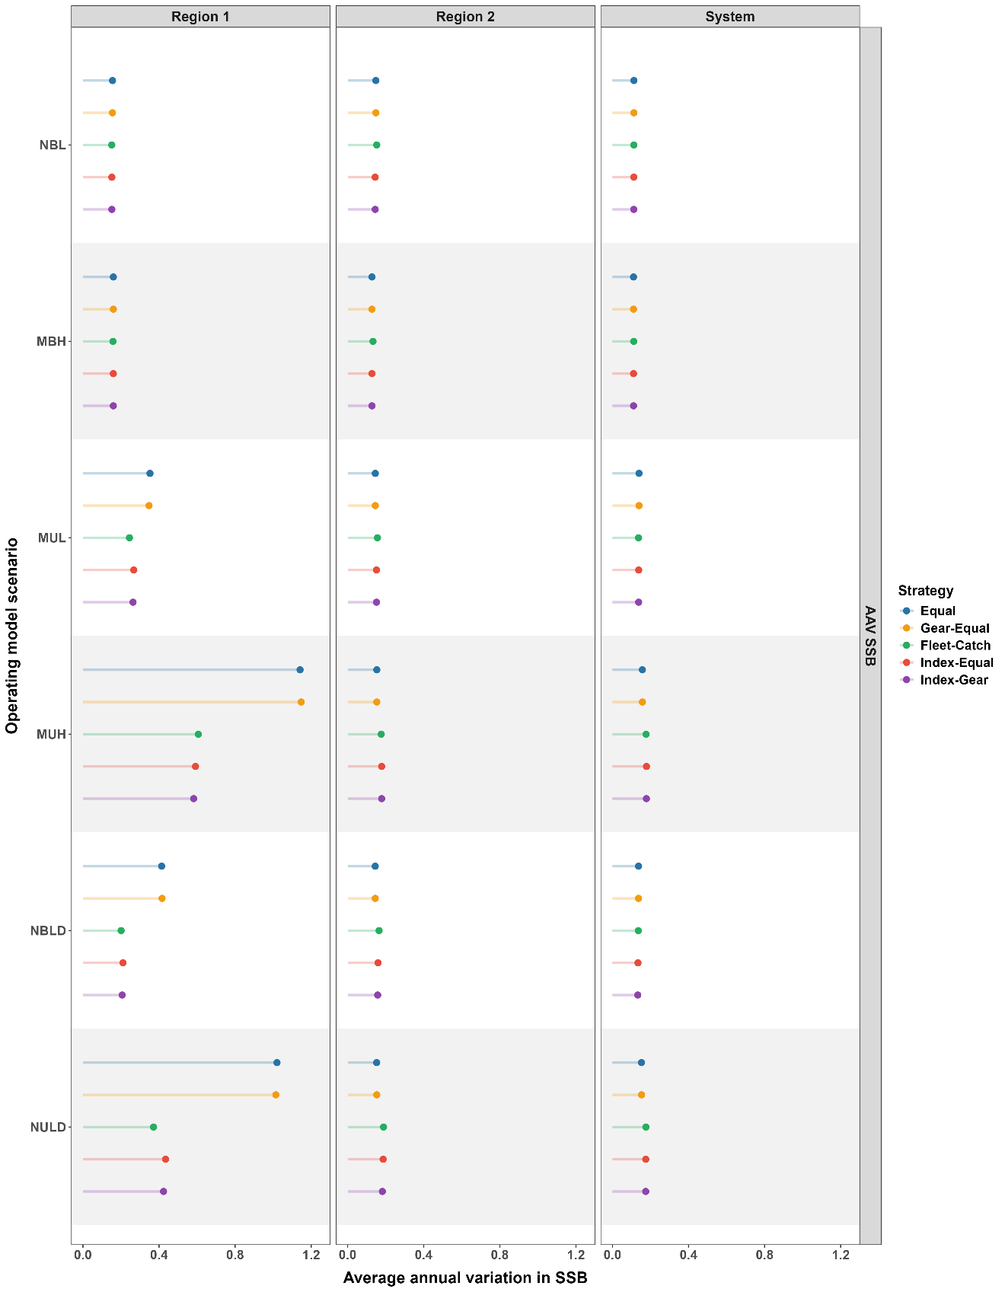
Figure S4. Probability of overfishing across catch allocation strategies, spatial scales, and the six main-text operating model scenarios. Probabilities were calculated over the feedback period from the proportion of years in which fishing mortality exceeded the scenario-specific reference level.
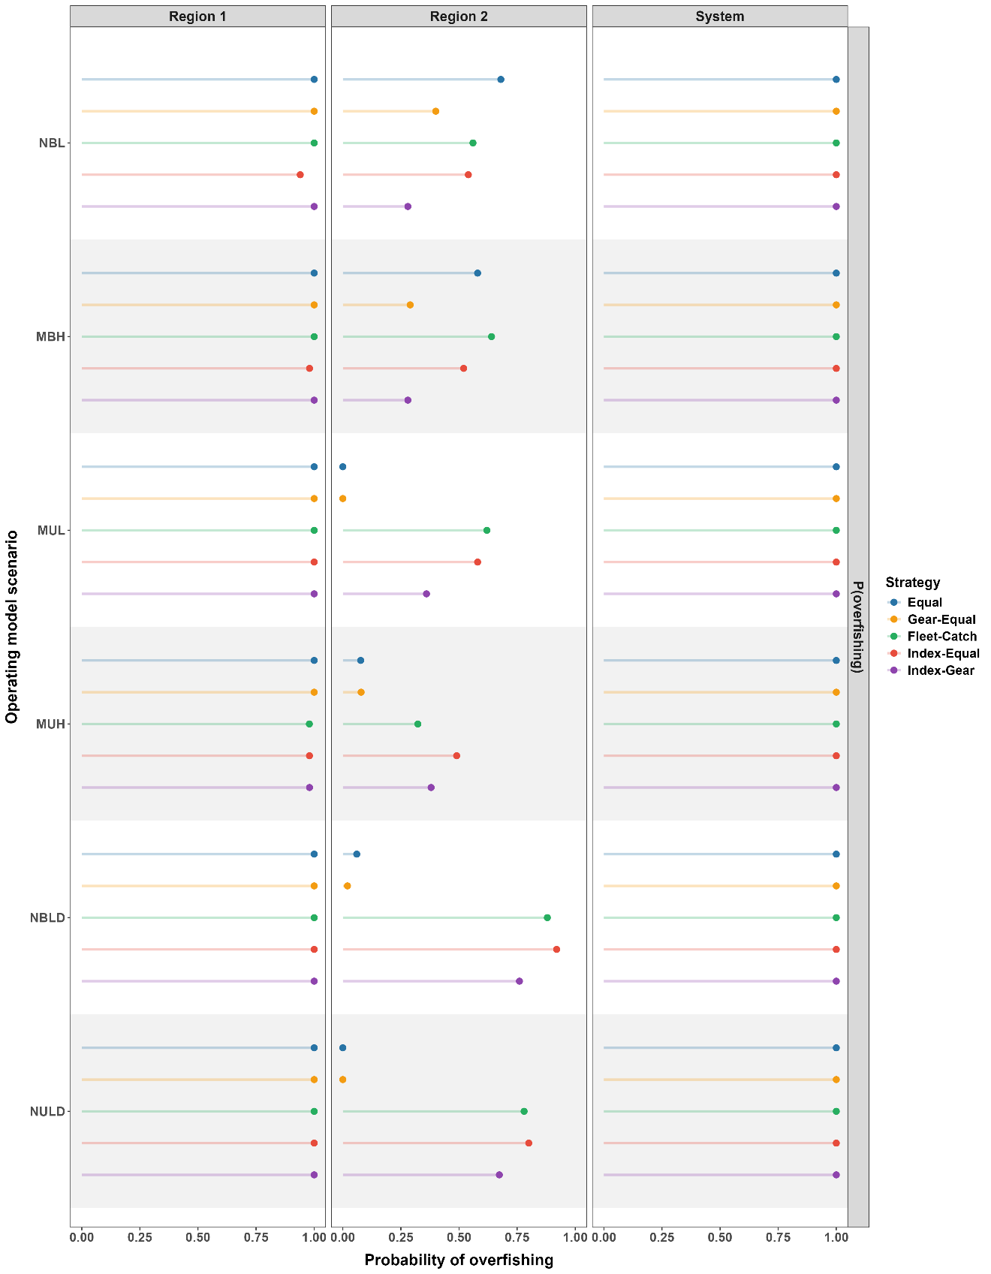
Figure S5. Probability of being overfished across catch allocation strategies, spatial scales, and the six main-text operating model scenarios. Probabilities were calculated over the feedback period from the proportion of years in which SSB fell below the depletion threshold.

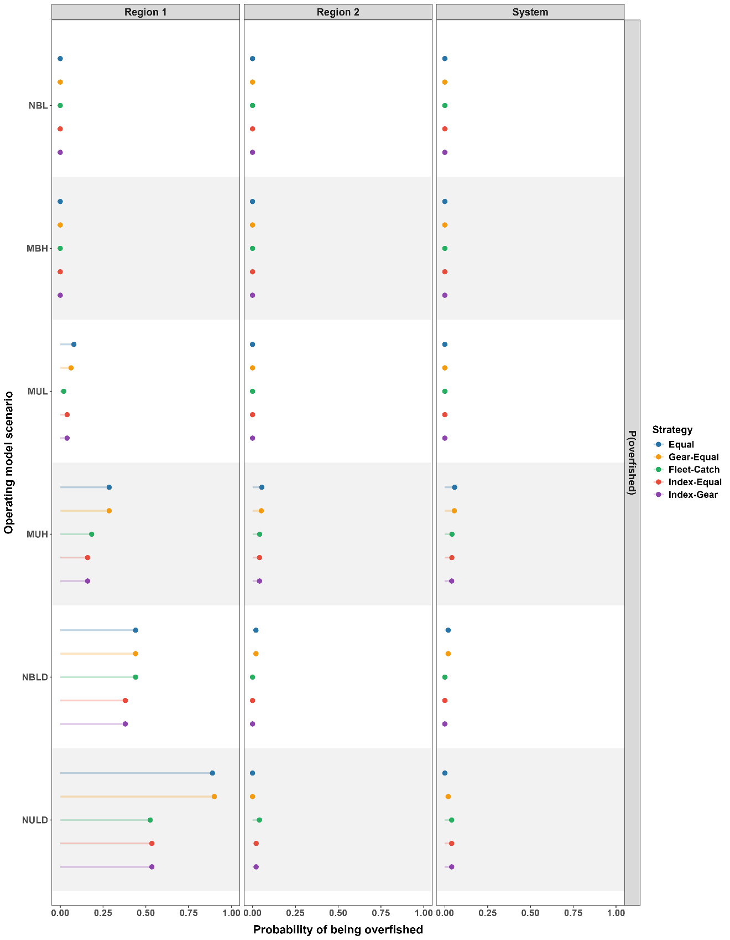
Figure S6. Short- and long-term catch performance across catch allocation strategies, spatial scales, and all operating model scenarios. Median catch is shown on the absolute catch scale for Region 1, Region 2, and the system-level aggregate. Points show medians across retained realizations; horizontal error bars show interquartile ranges (25th-75th percentiles).
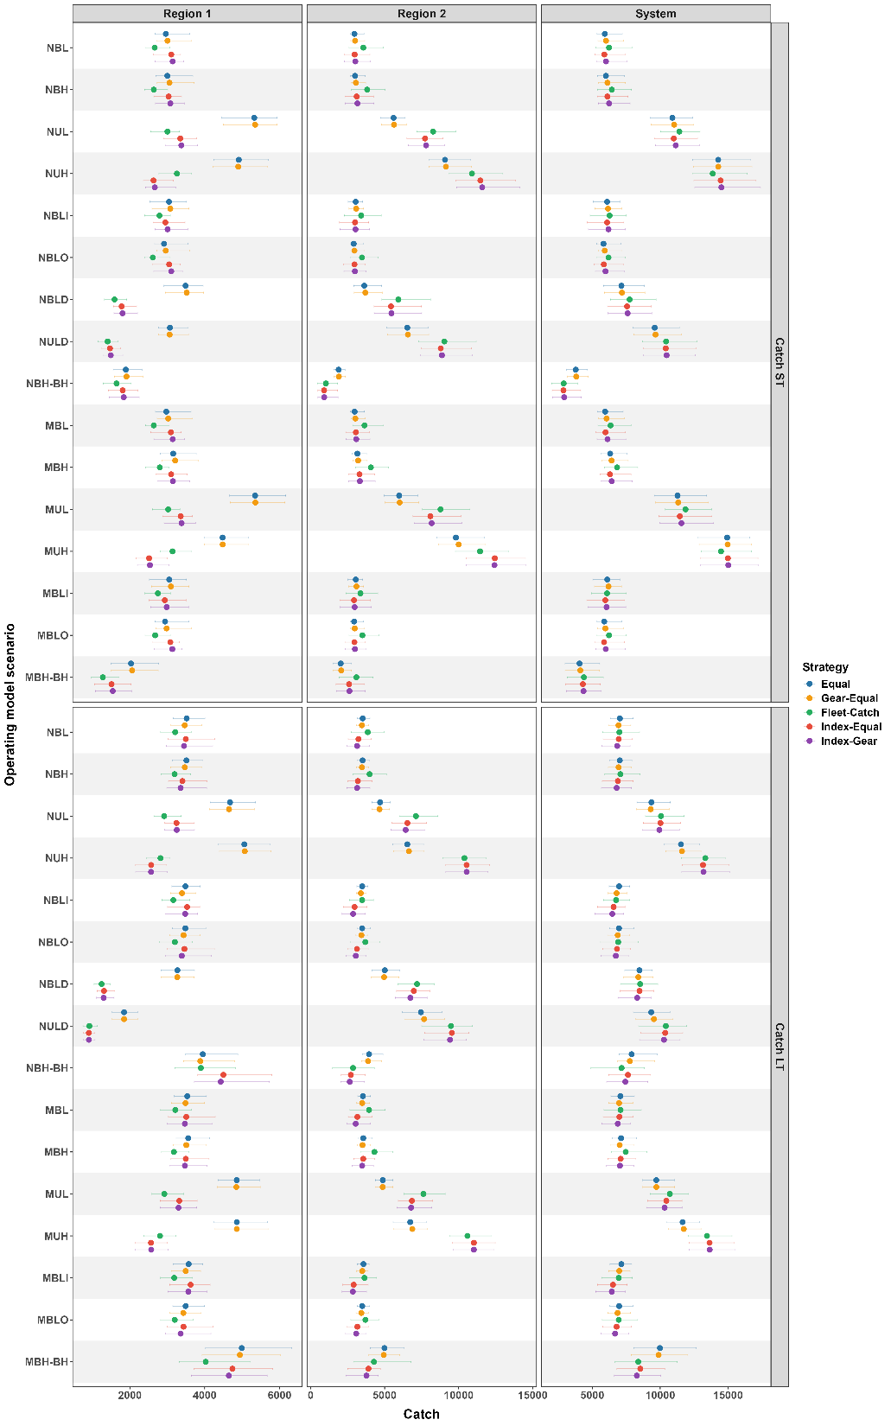
Figure S7. Short- and long-term spawning stock biomass (SSB) across catch allocation strategies, spatial scales, and all operating model scenarios. Median SSB is shown on the absolute SSB scale for Region 1, Region 2, and the system-level aggregate. Points show medians across retained realizations; horizontal error bars show interquartile ranges (25th-75th percentiles).
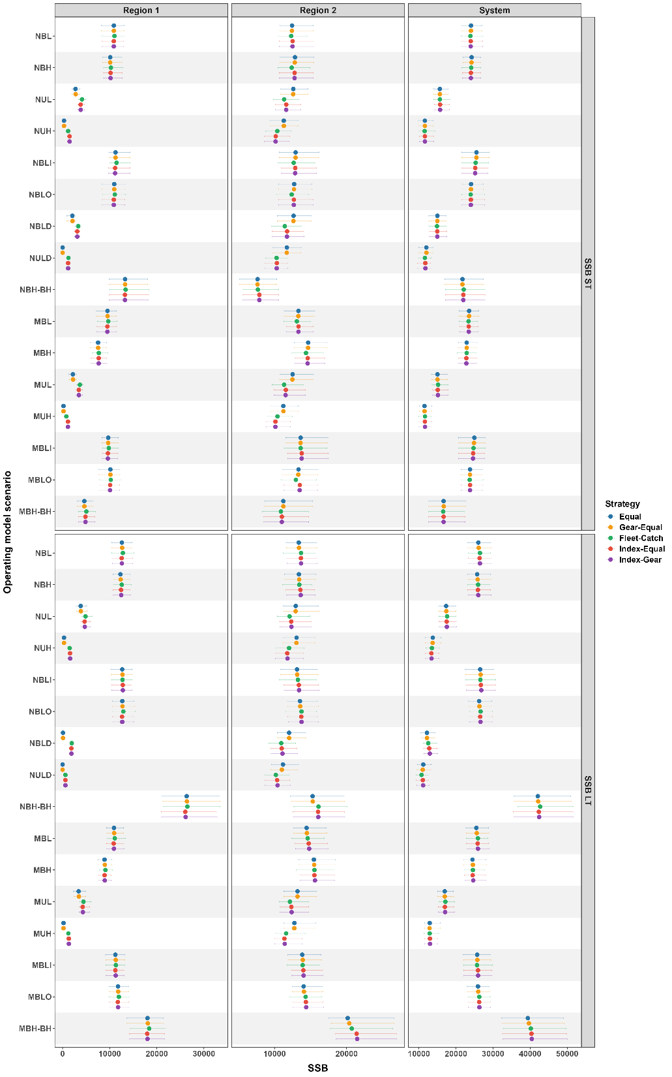
Figure S8. Average annual variation (AAV) in catch across catch allocation strategies, spatial scales, and all operating model scenarios. Lower values indicate more stable catch over the feedback period. Points show medians across retained realizations; horizontal error bars show interquartile ranges (25th-75th percentiles).
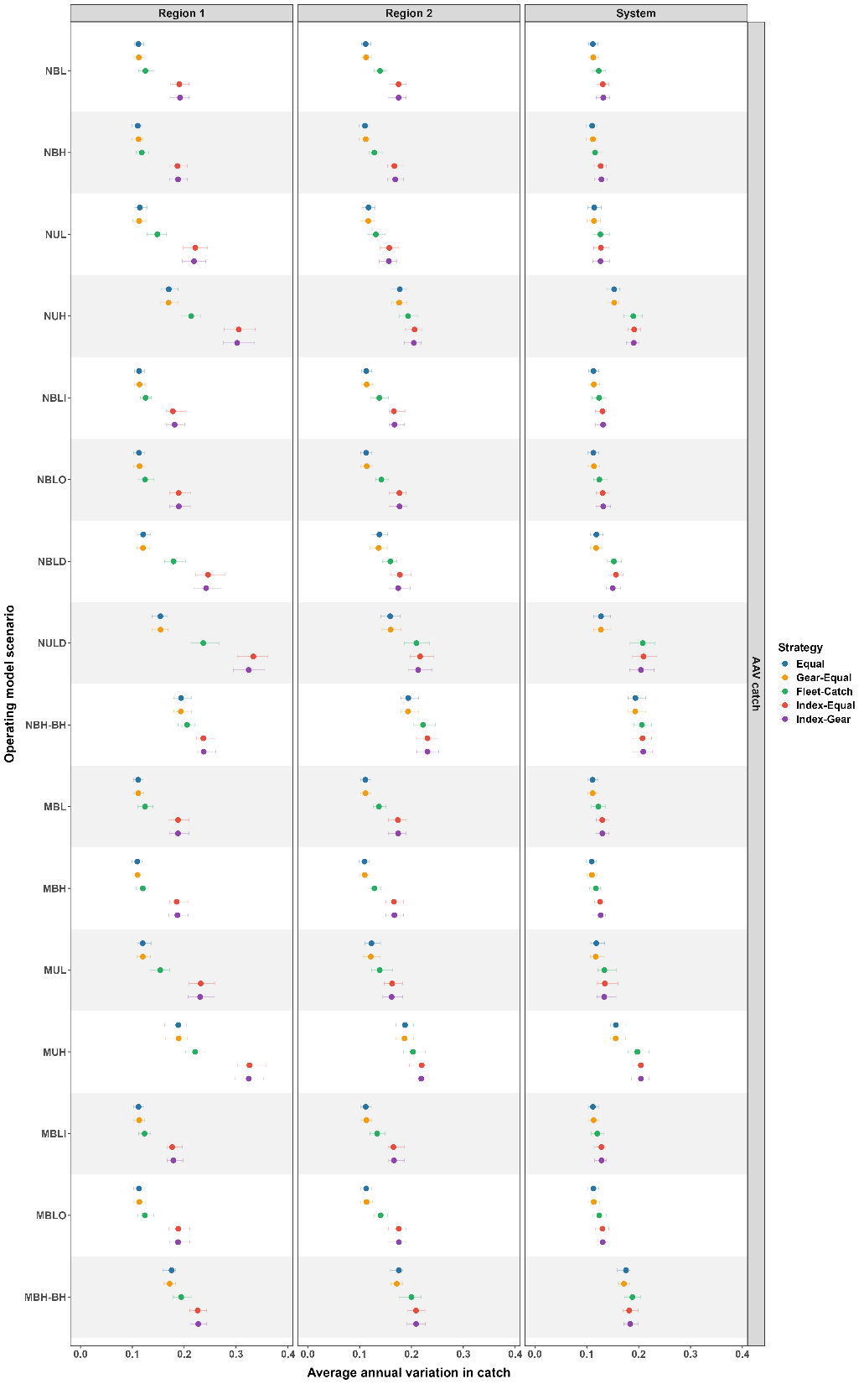
Figure S9. Average annual variation (AAV) in spawning stock biomass (SSB) across catch allocation strategies, spatial scales, and all operating model scenarios. Lower values indicate more stable SSB over the feedback period. Points show medians across retained realizations; horizontal error bars show interquartile ranges (25th-75th percentiles).
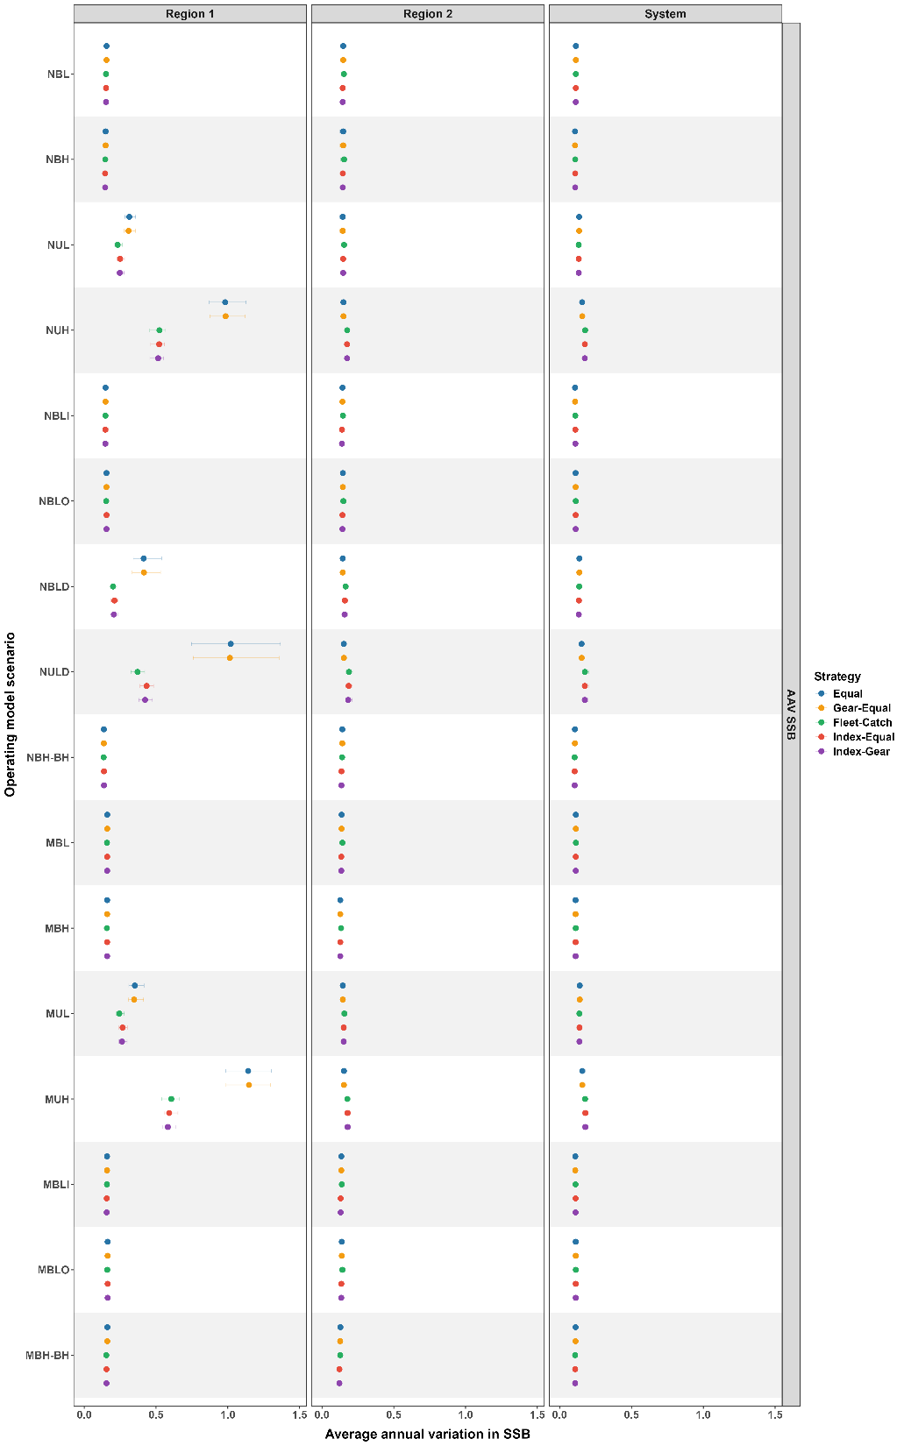
Figure S10. Probability of overfishing across catch allocation strategies, spatial scales, and all operating model scenarios. Probabilities were calculated over the feedback period from the proportion of years in which fishing mortality exceeded the scenario-specific reference level. Points show medians across retained realizations; horizontal error bars show interquartile ranges (25th-75th percentiles).
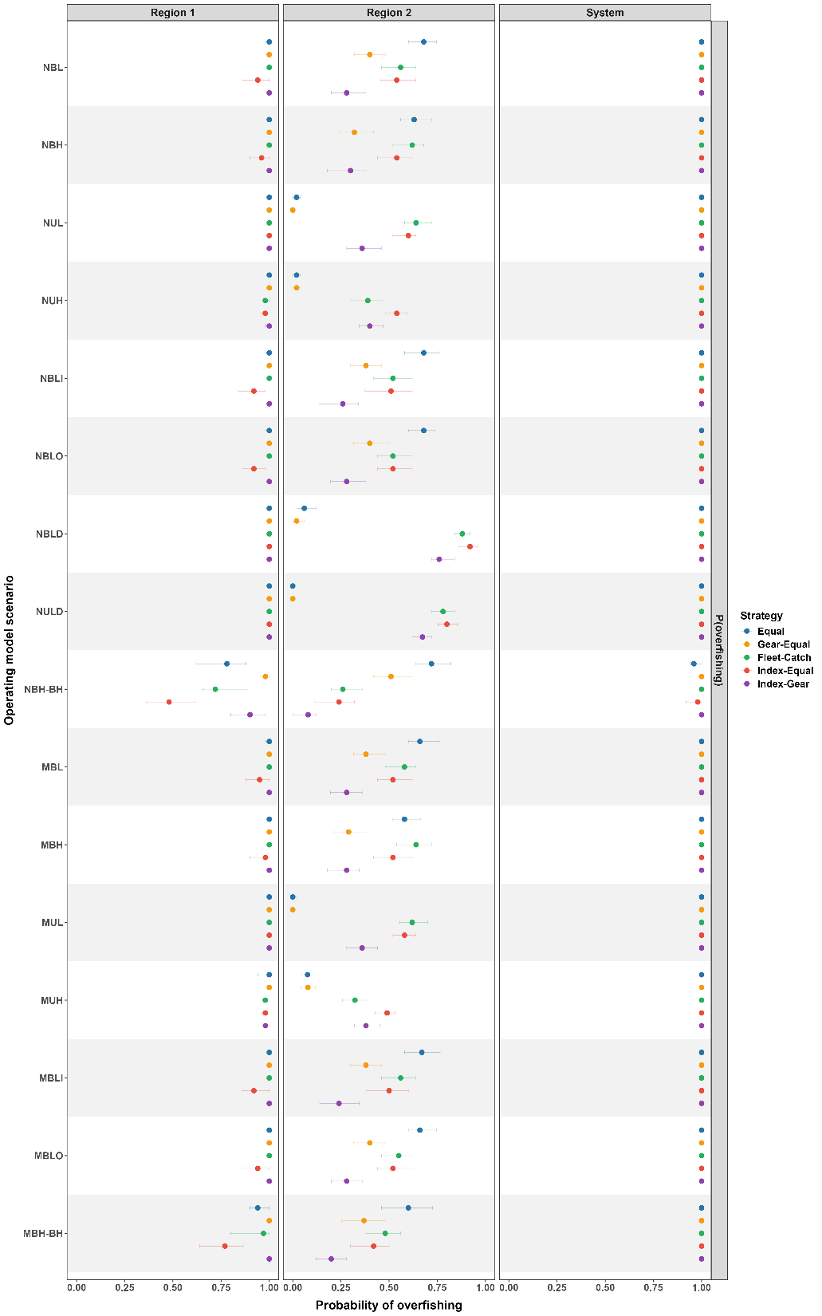
Figure S11. Probability of being overfished across catch allocation strategies, spatial scales, and all operating model scenarios. Probabilities were calculated over the feedback period from the proportion of years in which SSB fell below the depletion threshold. Points show medians across retained realizations; horizontal error bars show interquartile ranges (25th-75th percentiles).
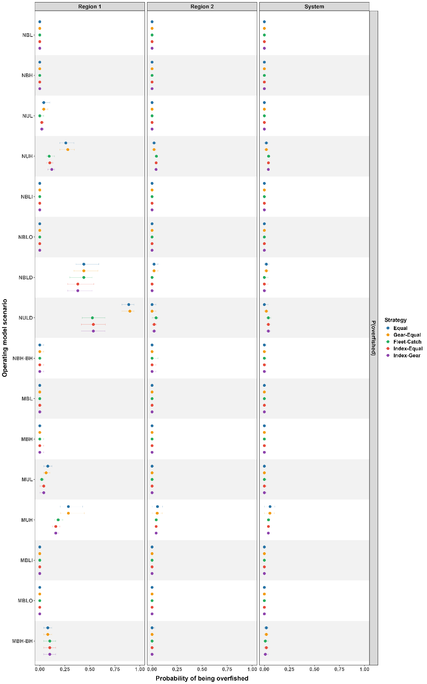
Figure S12. System-level performance scores for each operating model scenario. Scores summarize normalized catch, spawning stock biomass (SSB), average annual variation, probability of overfishing, and probability of being overfished across catch allocation strategies, and average scores across metrics are shown at the top of each plot. Higher scores indicate more desirable outcomes after min-max scaling within each operating model scenario and spatial scale.
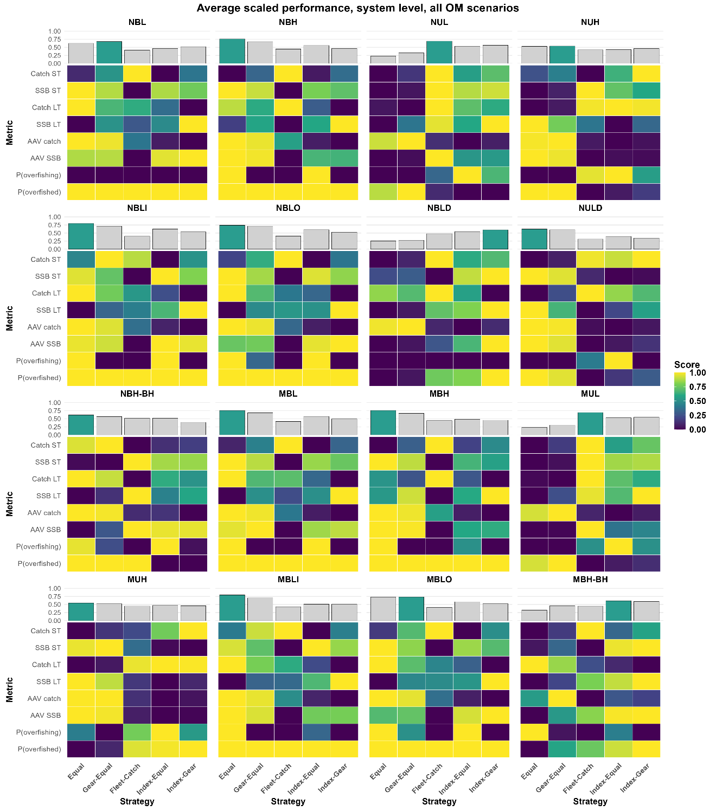
Figure S13. Region 1 performance scores for each operating model scenario. Scores summarize normalized catch, spawning stock biomass (SSB), average annual variation, probability of overfishing, and probability of being overfished across catch allocation strategies, and average scores across metrics are shown at the top of each plot. Higher scores indicate more desirable outcomes after min-max scaling within each operating model scenario and spatial scale.
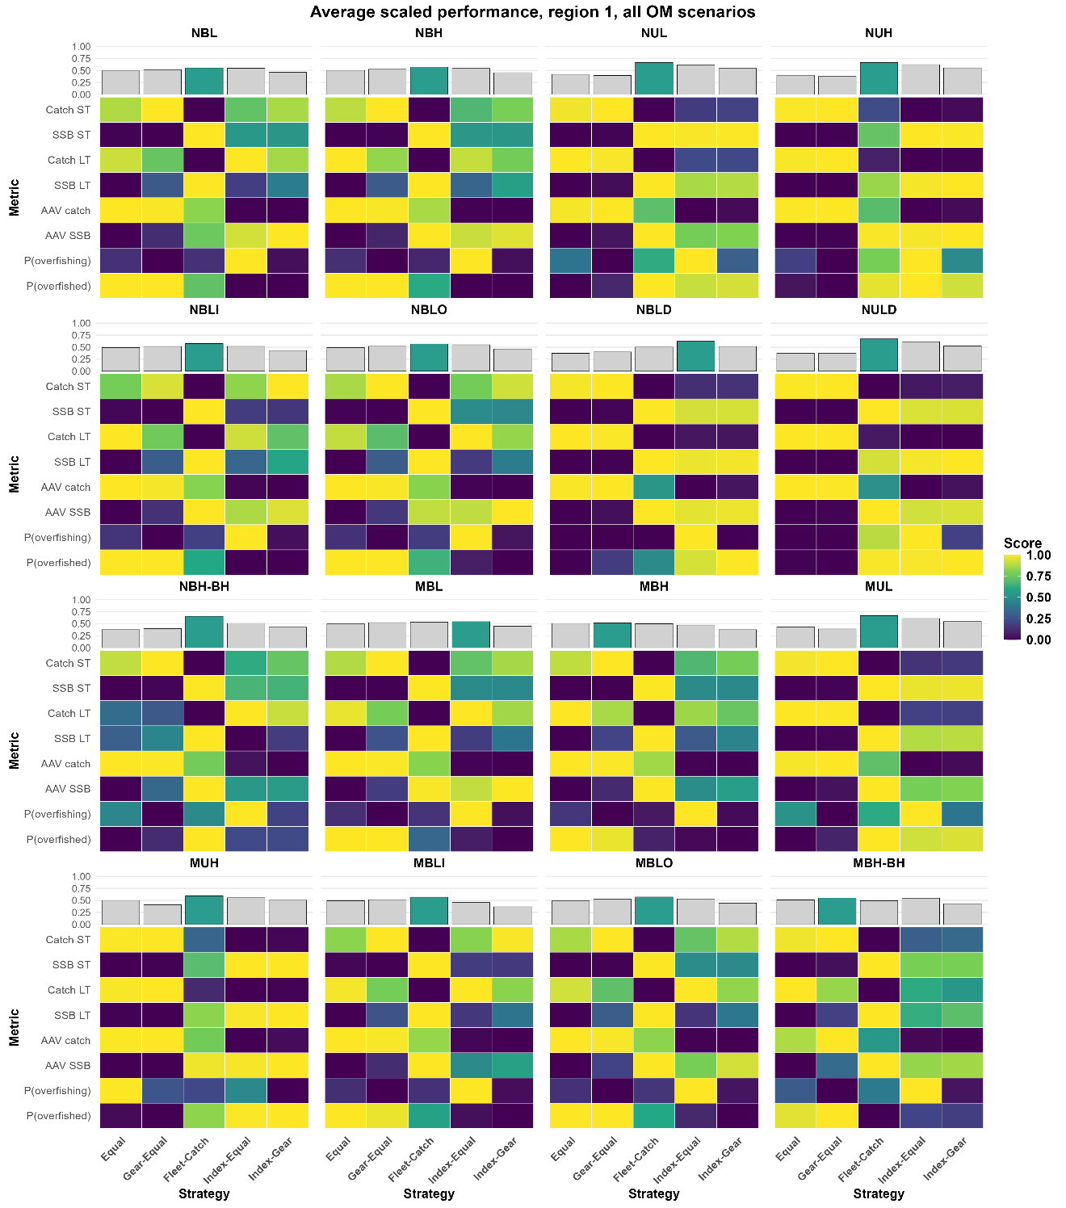
Figure S14. Region 2 performance scores for each operating model scenario. Scores summarize normalized catch, spawning stock biomass (SSB), average annual variation, probability of overfishing, and probability of being overfished across catch allocation strategies, and average scores across metrics are shown at the top of each plot. Higher scores indicate more desirable outcomes after min-max scaling within each operating model scenario and spatial scale.


